Heidelberg MLA150 Operating Instructions

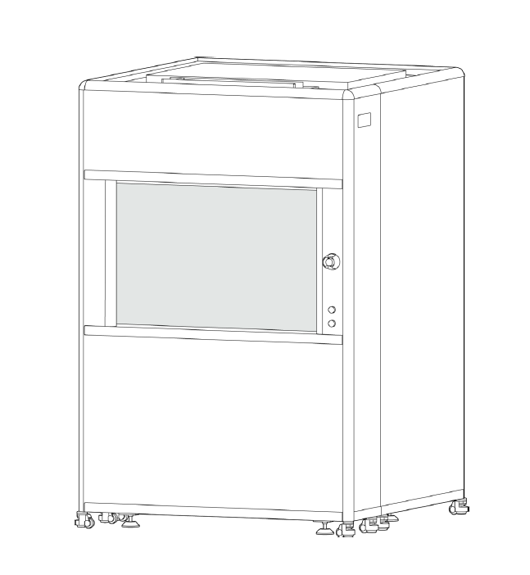

General Precautions

Contacts
For problems, clarifications of procedures, or general information pertaining to this machine, please contact the lab staff:

Lab staff email: staff@nd.edu

In case of emergency, Please contact the Notre Dame Security at 1-5555 or 911

Warnings:

1 – Do not leave alignment jigs inside the machine – serious equipment damage will occur if left on stage.

2 – Do not use pneumatic alignment with small pieces

3 – min sample size is 10 mm x 10 mm

4 – No Metal Tweezers

System will follow the workflow:
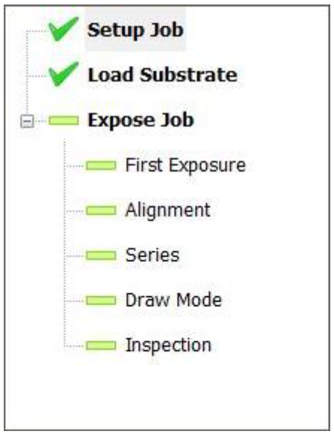

Load Substrate

Enable the machine in iLab

Ensure stage is at unload position

Open door

Insert jig and align for 4” wafer

Insert Flat on alignment jig
- Apply vacuum
- REMOVE JIG!!!!!
- Close door
- Press Load substrate
- Continue
  - System moves to load under center
- 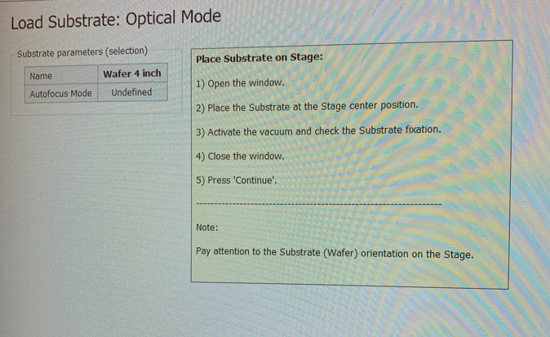
- Confirm substrate is centered under write head
- 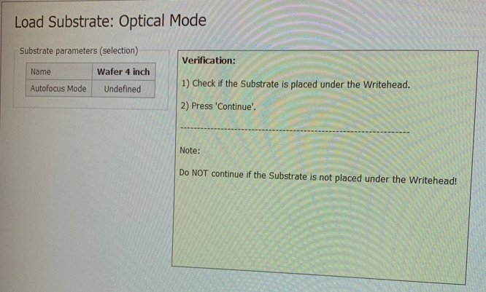
- Continue
  - System will focus
  - System will center substrate
- Alignment if second layer – See alignment section
- Start Exposure

Converting a Design
- Save File to desktop/design/file type/create user folder
- Open GUI HIMT Converter (X) or Convert Design in JOB
- 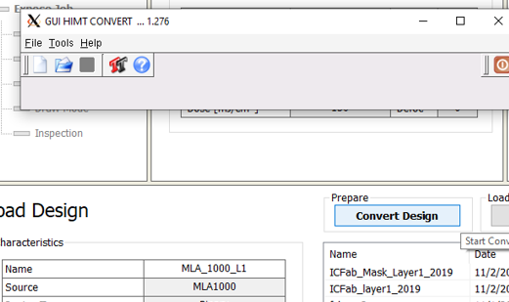
- File
- New Job
- Give it a name – nothing fancy, no characters
- Add – select file type (ex: gdsii)
- 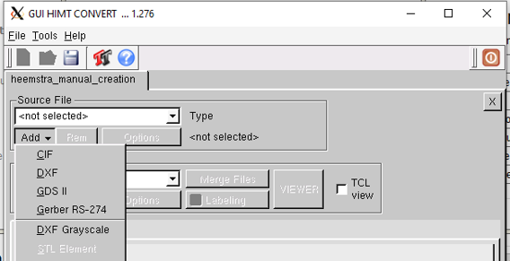
- Open folder
- File – Open
- STEPPER MASKS – must increase scale (X and Y) to 5 to print 5x

- Select layer to convert
- 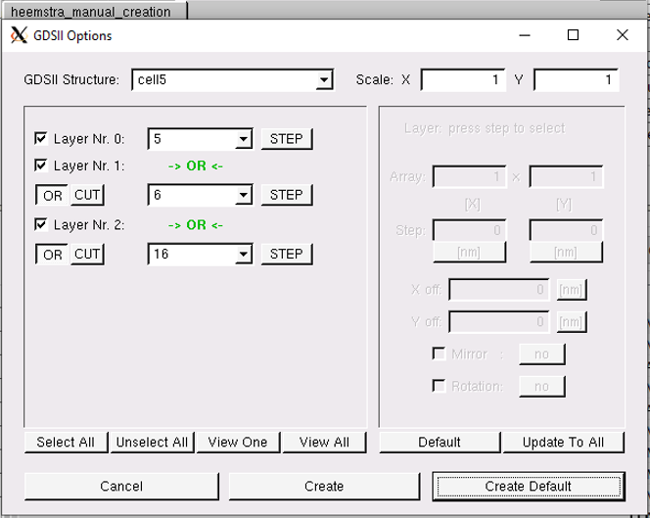
- Create Default
- Viewer – allows you to see conversion file
- 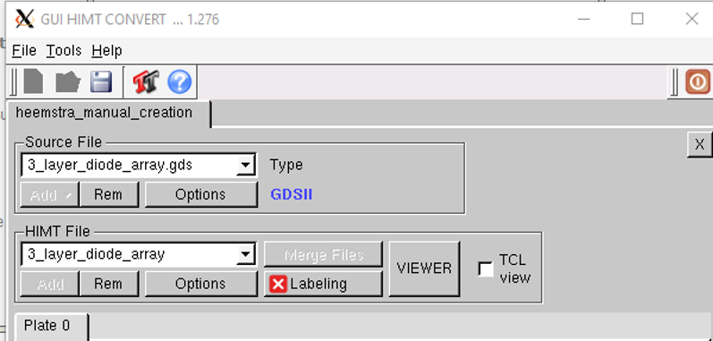
- File – Save Job as HIMT.job file for use in exposure (home/convert/gui/jobs/yourfile.job)
- Complete Task (exit)

Setup Job

- Select new or load an existing job.
- All Jobs – fill in Green information
  - You do NOT have to select a resist
  - You can change dose prior to writing
  - If resist and laser selected do not match you will get a warning but the system will write with the laser that has been selected.
- Types of jobs:
  - Standard – What is written in gdsii or conversion file
  - Series – Focus and/or Exposure matrix
- Select substrate type
- 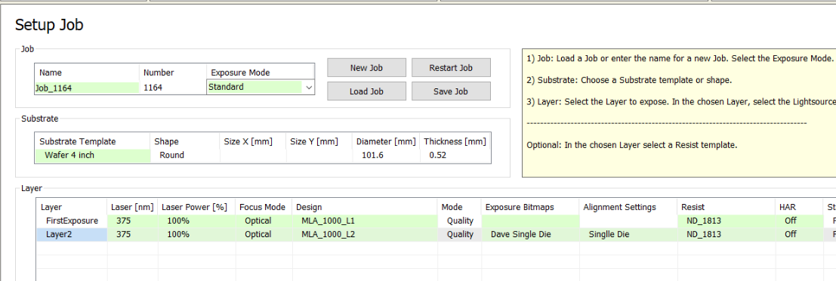
- 1st layer does not need Alignment Settings
- Subsequent layers will require Alignment Settings
- BLUE line exposure layer

Alignment

Load job and sample

Move to 1st alignment markter (cross or square)
- Measure
- Accept Position if good
- System moves to 2nd alignment marker
- Measure
- Accept position if 2nd alignment is good

Small Parts and Pieces

Place small parts jig in machine

Install sample – push towards left side of alignment jig

Open job

Select “Small” for substrate

Select exposure – change alignment mode to MANUAL if second layer
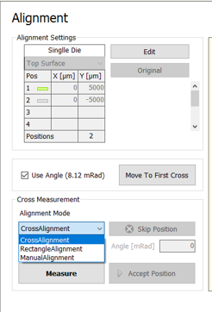

Select Optical Focus Pneumatic Focus WILL NOT WORK on small pieces

Load sample

Might have to change magnification on microscope

Center on piece

Running a Focus Exposure Matrix
- Load Job – MLA_1000_L1 or FE2MIN
- Configure Substrate for correct information
- Select SERIES
- Select Defocus and/or Exposure – select range and increments

Mask Making Process

- Include substrate cost in iLab reservation
  - Listed under “add additional service charges”
- REMEMBER – 5x scaling is needed (X and Y) in job conversion if you are making a stepper mask!!
- Place 0, 0 in the center of your design
- All Masks will be inverted – use caution with text unless you flip horizontally

- Expose 4” or 5” mask substrate in MLA system
- Develop – AZ917 – 25 to 30 sec
- Rinse in DI – Inspect
- Chrome Etch ~65 sec CR-4 (loading dependent)
- Rinse in DI – inspect with transmitted light
- PR removal – rinse in ACE/IPA
- Drytek 5 minutes

Alignment Markers
Ex below – From Center of Die:
- Top Cross at (0, 5000)
- Bottom Cross at (0, -5000)

Standard Cross is 16 um wide at center
Square – Info needed
