Corial ICP Operation Instructions

At

University of Notre Dame

Department of Electrical Engineering

Contacts
For problems, clarification of procedures, or general information pertaining to this machine please contact send email to staff@nd.edu

In case of emergency, please contact the Notre Dame Security at
911

General Precautions

- Serious Equipment Damage will occur if you do not use the bubble level to verify correct puck placement inside the load lock
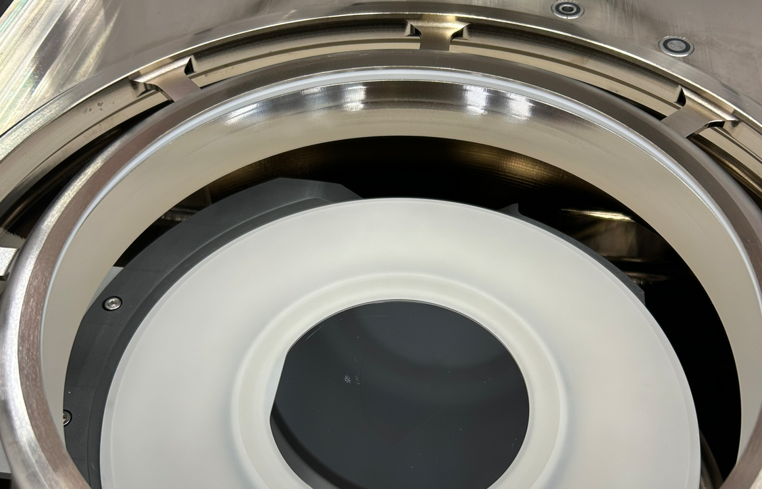
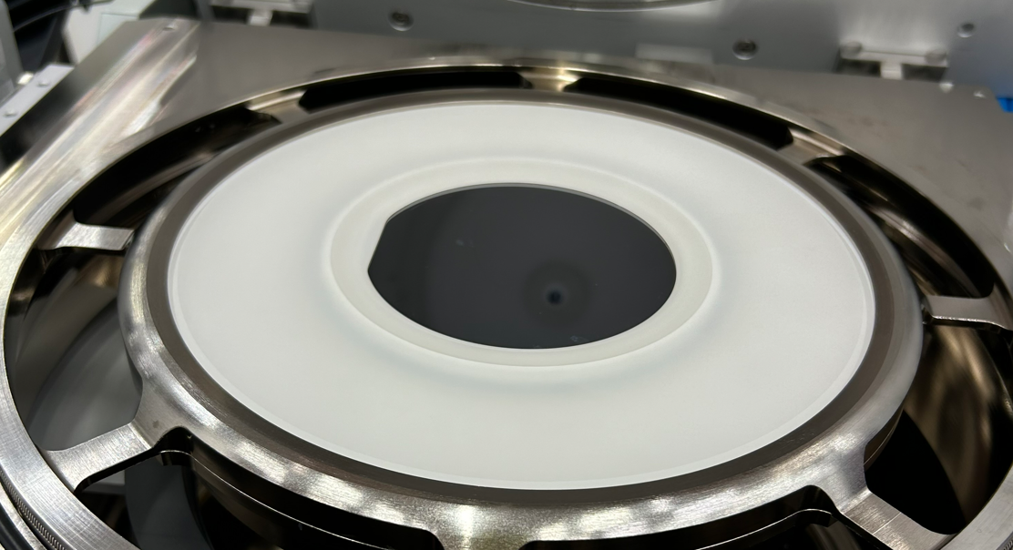

- Serious Equipment Damage will occur if you leave the bubble level inside the load lock

- Pucks can become very hot and are very fragile – please do not touch them when hot

- The Five (5) piece quartz puck MUST have a full 100 mm wafer in it in order to use. BS Helium will not function without a full wafer.

- Pucks (Quartz and 5-piece wafer) are never to be left on tables or on top of the machine. They must remain inside the blue boxes or inside the machine. Five pieces are 2 – quartz rings, 1 blue oring, 2 metal plates
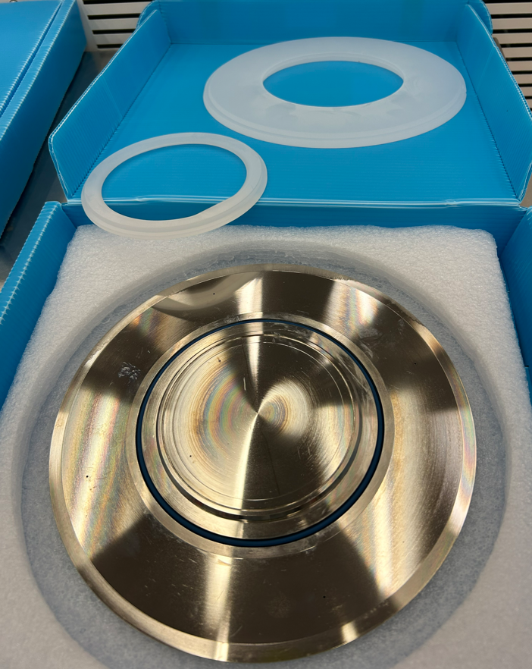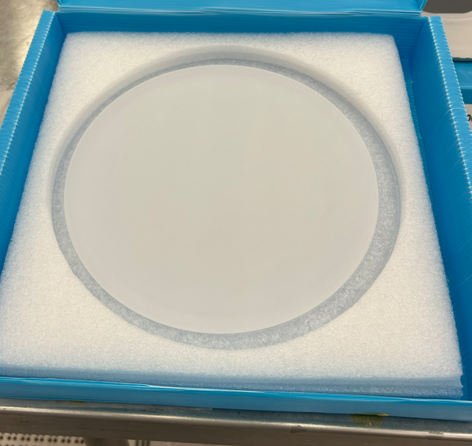
- You must include a 5 second bias plasma ignition step in order to assist with ICP plasma ignition. You must also include two post etch pumps and evacuation steps
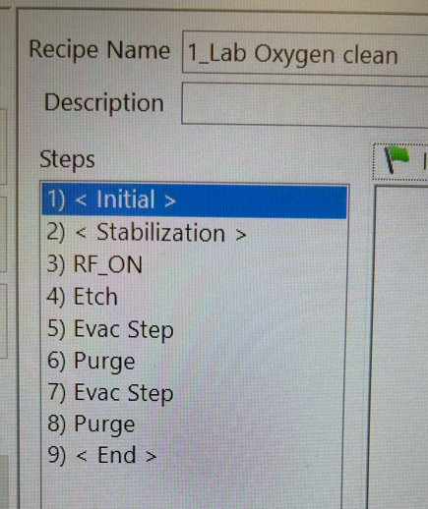

- You MUST return cathode Temp to “Set Standby” temperature when finished.
- ICP bias voltage CAN NOT Exceed 2000V – errors will occur
- You MUST be present at the machine and monitoring the system anytime RF is turned ON

Running a Sample

Enable the machine in iLab
- On the ICP computer, go to “Handler”, then “Transfer”, and “Vent Lock” to vent the Load Lock chamber.
- Once at ATM – gently open the lid
- Select either:
  - Single piece quartz puck
  - Five (5) piece 100 mm wafer puck and assemble correctly – two quartz pieces, 1 blue oring and 2 metal pieces compose up the 5-piece puck. It Must have a full 100 mm wafer in it in order to use. BS Helium faults will occur if there is not a wafer.

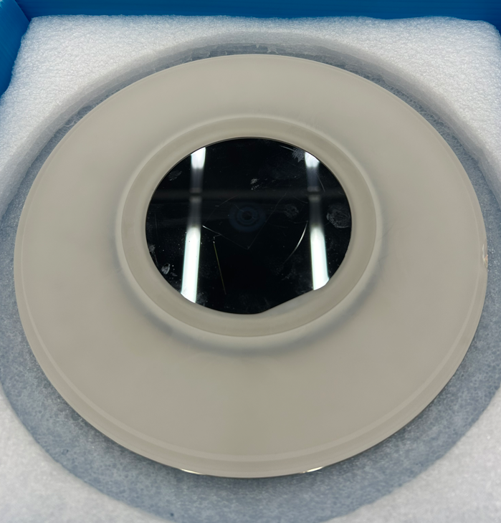

- Install puck of choice in the load lock and verify rotation.

- SET THE BUBBLE LEVEL ON AND VERIFY 50% or more of the bubble is in the middle of the center
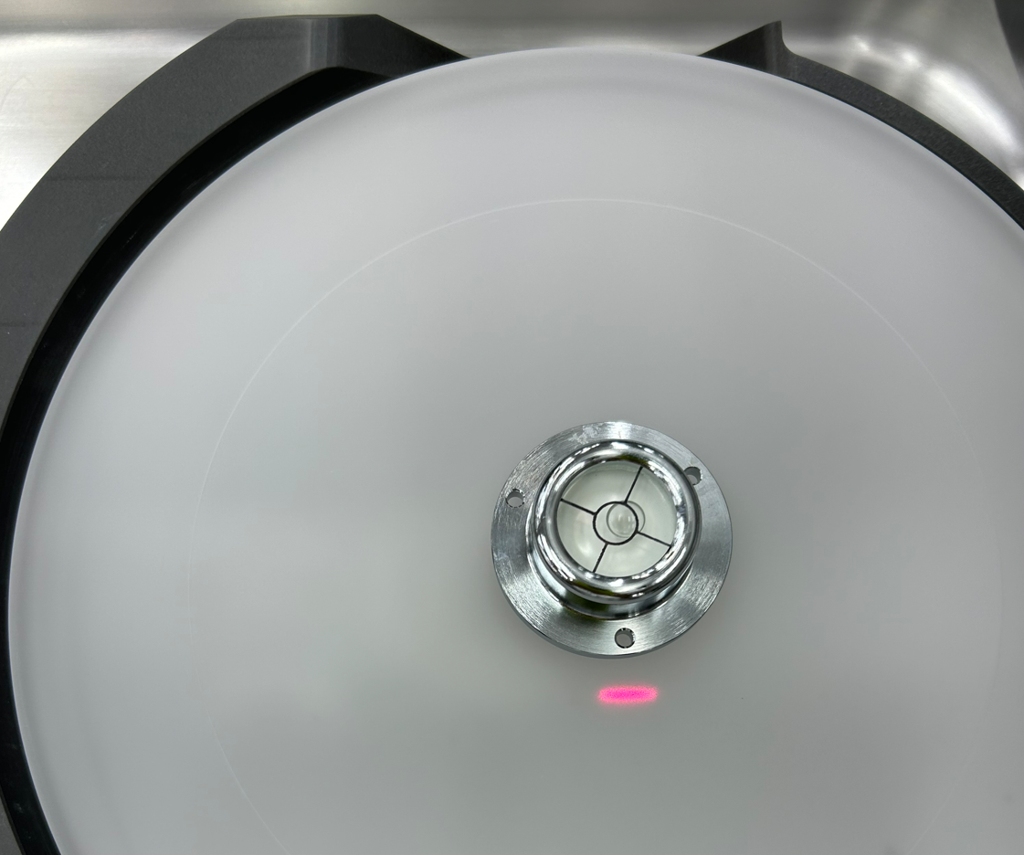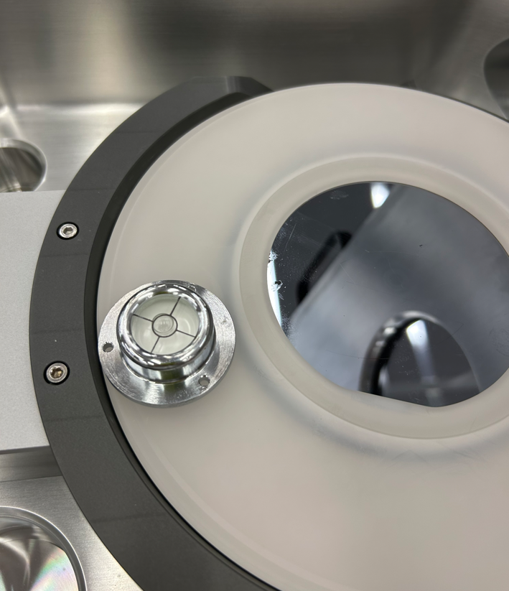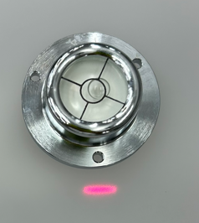
- REMOVE BUBBLE LEVEL – failure to not remove this can cause serious equipment damage.
- Close Lid

- On the computer go to “Handler”, then “Transfer” and “Pump Lock”
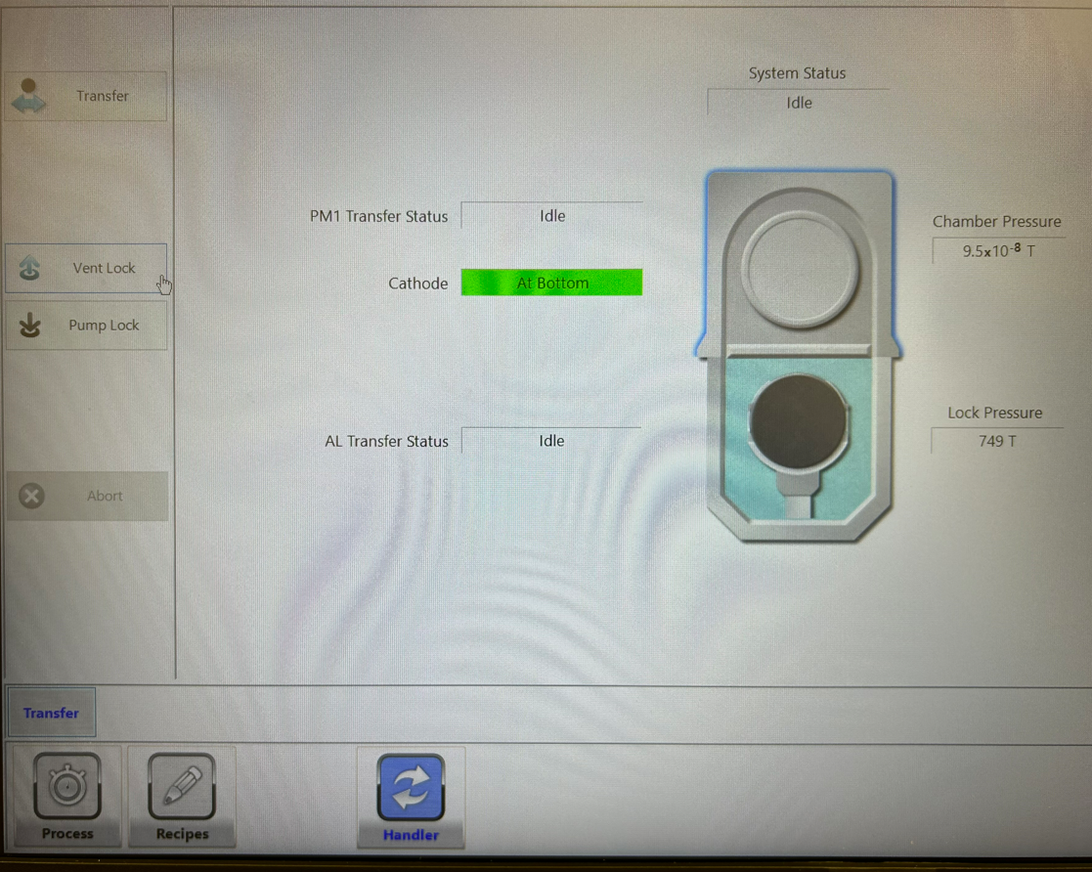

- Allow load lock pressure to reach “Pumping Idle” on status screen – this may take about 1 minute
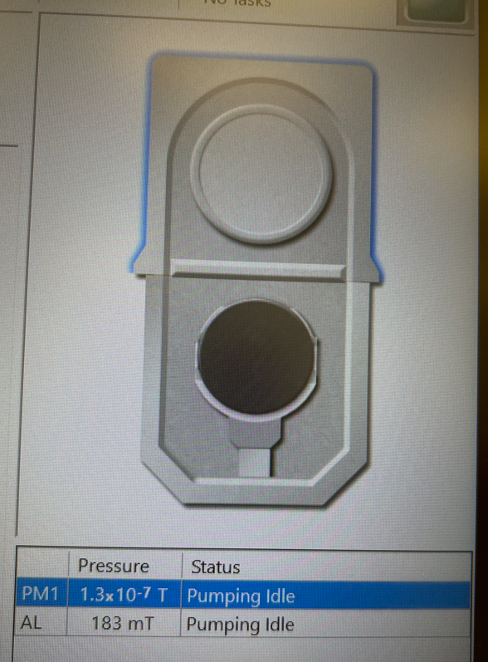

- Select “Transfer” and allow the puck to transfer into the system.
- Go to the “Process” tab – then “Start Job”
- Load Recipe and enter Job ID name
- Select “Start Job” button
- Allow process to complete
- From “Handler” – “Transfer” tab – select “Transfer” to return the puck back to the load lock.
- Allow the load lock to return to “Pumping Idle” status
- From the “Handler” “Transfer” tab – select “Vent Lock”
- Allow the load lock to vent to atmosphere.
- Open lid – VERIFY PUCK IS NOT TOO HOT TO HANDLE and remove only when safe to do so.
- Place puck into blue box
- Close lid
- Select “Pump Lock” when finished
- Set “Standby Temperatures” when finished
- Clean up the equipment, samples, trash and accessories you may have used.
- Disable machine in iLab.

Making a Process Recipe

- From the “Recipe” mode, go to “Edit Recipe”, then “Load”
- Select 1_Lab Oxygen Clean
- Change Recipe Name and Select “SAVE” after confirming “Engineering” type
- Place net ID in Description section – additional info (ER, DC Bias) is optional
- To modify recipe – you will need to modify the following steps:
RF On and Main p and main etch steps to the gas flow, pressure and RF Powers that you desire.
  - Initial – Temperature Definition Step
  - RF On – Gas Flow, Pressure and RF Bias Strike power
  - Etch – Gas Flow, Pressure, RF Bias, RF ICP power, etch time

